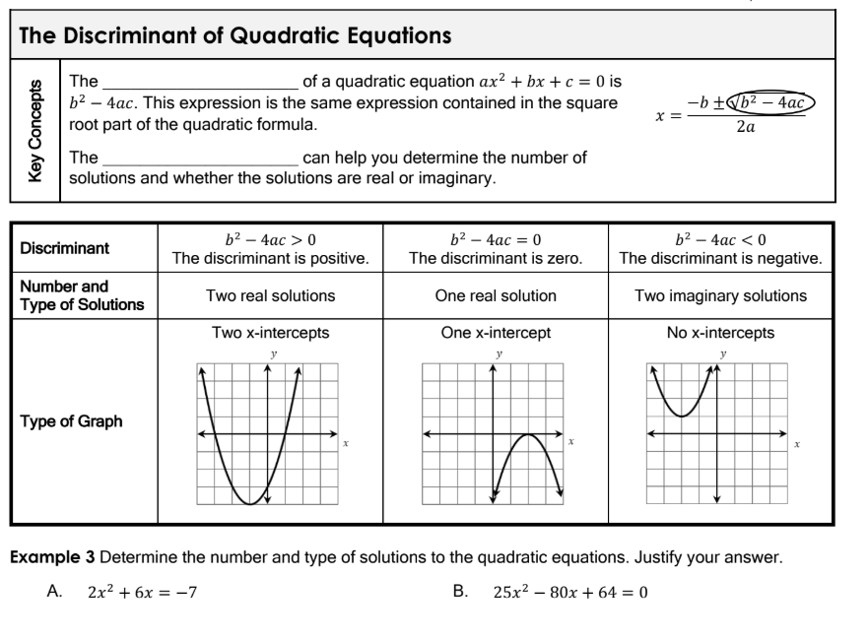

4. The quadratic equation $f(x)=3x^{2}-5x+c$ has two distinct real solutions. Use the discriminant to find all possible values of c.

5. The quadratic equation $f(x)=ax^{2}-6x+1$ has two distinct real solutions. Use the discriminant to find all possible values of a.

6. The quadratic equation $f(x)=-x^{2}+4x+c$ has no real solutions. Use the discriminant to find all possible values of c.

